The nature reserve "Bolshaya Kokshaga"
The nature reserve Bolshaya Kokshaga is situated in Kilemarsky and Medvedsky Districts of the Republic of Mari-El. It was founded in 1993. Its area is 21,4 thousand ha. The nature reserve is located on along the sides of the river Bolshaya Kokshaga.
The mouth of river Bolshaya Kokshaga is marshy.
The Zapovednik is located on the border of southern taiga and broad-leaved forests. In the plant cover of the area pine forests prevail (with lichen ['laɪkən лишайник, bilberry['bɪlb(ə)rɪ] ; черника and bog moss торфяной мох, сфагнум ); great areas are occupied by birch forests. Along the Bolshaya Kokshaga oak- forests with elm trees grow. Sometimes black alder (['ɔːldə] ольха) forests can be met.
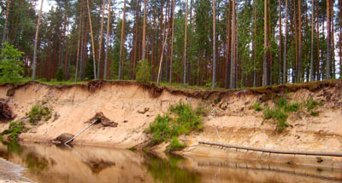
Flora extends over more than 600 plant species; fauna is typical for similar forest. There are noted: 200 birds species, 52 mammal (['mæm(ə)l] млекопитающее) species, 16 reptile species, 25 fish species. Elk, alpine hare and squirrel are numerous; wild boar live on the territory. Of predators the most well known are the marten, least weasel, fitchew, and common weasel; brown bear and wolf are met. Of bird species wood grouse and black grouse are common. Crane, common heron, eagle owl, sparrow hawk nest in the Zapovednik. Of rare birds there are noted: black stork, serpent eagle, peregrine falcon, fish hawk.
In rivers and lakes there are pike, river darter, roach, tench, etc.

marshy ['mɑːʃɪ] болотный; болотистый
species ['spiːʃiːz] ; species 1) а) вид
Alpine ['ælpaɪn]
Alpine hare заяц-беляк
predator ['predətə] 1) хищник
marten ['mɑːtɪn] куница
least weasel ласка ['wiːz(ə)l]
fitchew ['fɪʧuː] 1) хорёк
common weasel горностай
wood grouse ['wudˌgraus] ; тетерев-глухарь
black grouse ['blækˌgraus] ; тетерев
crane [kreɪn] 1. 1) журавль
common heron серая цапля
heron ['her(ə)n] ; цапля
eagle owl филин
sparrow hawk 1) ястреб-перепелятник
black stork чёрный аист
serpent eagle змееяд
peregrine falcon ['perɪgrɪn] ['fɔː(l)k(ə)n] обыкновенный сокол, сапсан
fish hawk ; скопа
river darter речной дартер
roach I [rəuʧ] плотва
tench [ten(t)ʃ] ; tench; линь (рыба)

