Up to snowy mountain

We crossed the bridge.
We stopped the car.
We danced on the sand.
We played the guitar.

We cooked our food.
We washed our hands.
We jumped. One! Two!
We clapped our hands.

It’s a lovely trip.
A really lovely trip.
Driving to the mountains.
It’s a lovely trip.
A really lovely trip.
Up to snowy mountain.

Did the Irish ants arrive? 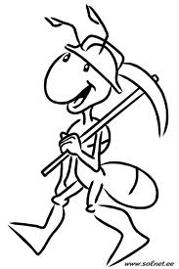

Did the Irish ants arrive? Yes, they did. Yes, they did.
Did they dance? Did they fly? Yes, they did. Yes, they did.
Did they ride? Did they drive? Did they swim across the sea?
Yes, they did. Yes, they did. Yes, they did.

Oh, they came to us from Ireland, across the Irish sea.
They ate all the biscuits. They didn’t eat the peas.
They brought us Irish butter, but they didn’t bring us cheese.
Oh, they came to us from Ireland, across the Irish sea.

Oh, they didn’t take the bus and they didn’t take the train.
They walked and they talked and they danced in the rain.
They didn’t take a taxi. Did they run and fly?
Yes, they did. Yes, they did. Yes they did.

